**Admin Manual Guide**

**Login**

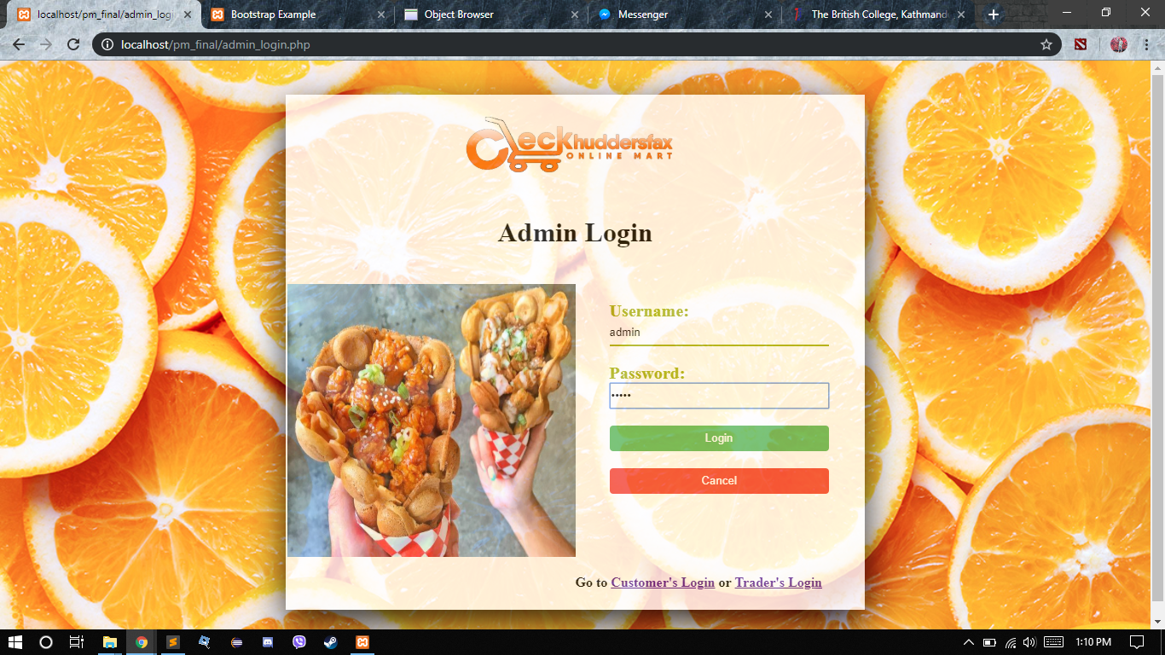

Admin should login to go through their dashboard by putting username and password which will lead them to dashboard.

**Admin Dashboard**

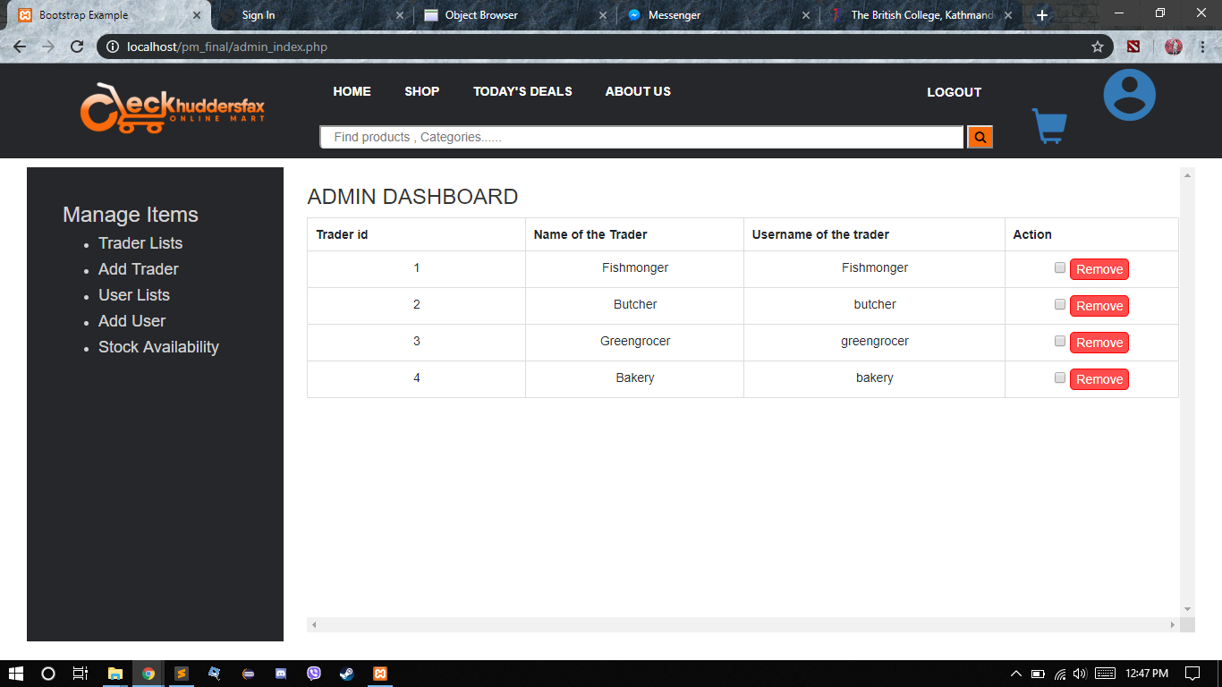

After logging in you will see the admin dashboard where you can find the five traders with their name and username and you can even remove the traders.

**Add_Trader**

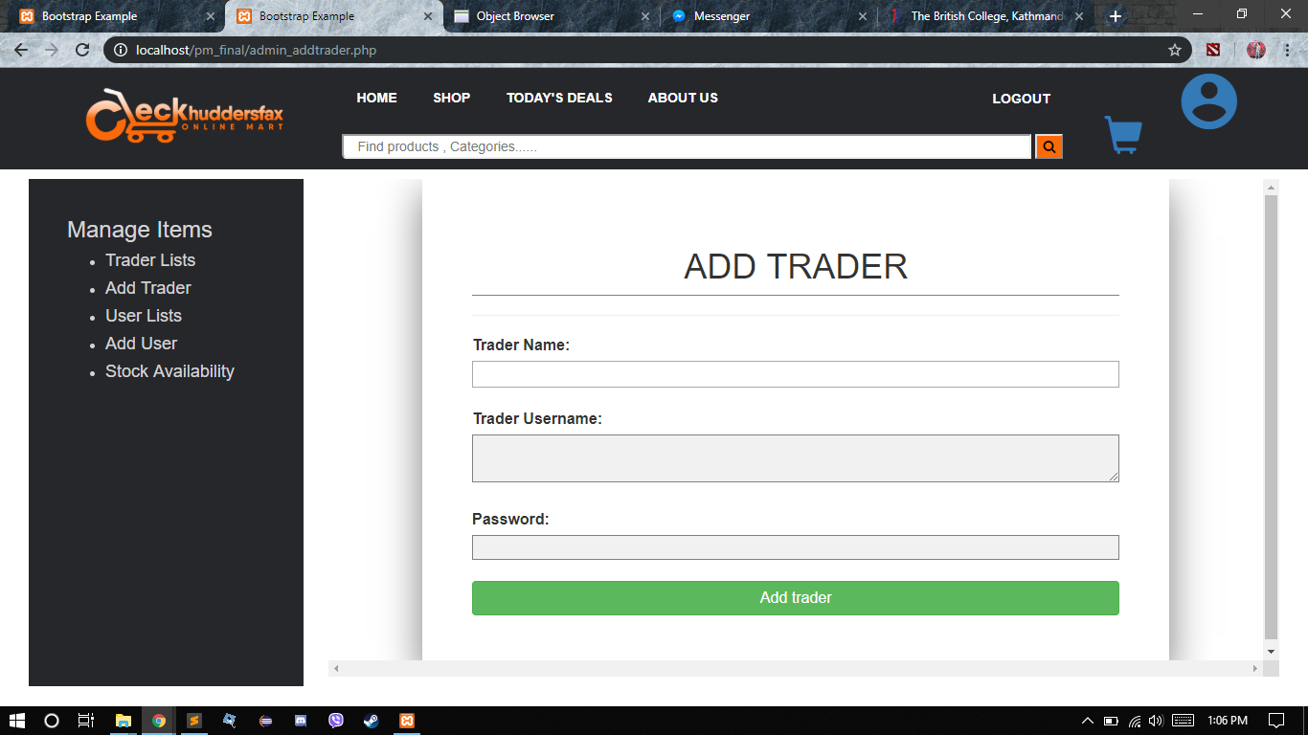

Admin can also add trader by adding their name, username and password.

**Add_user**

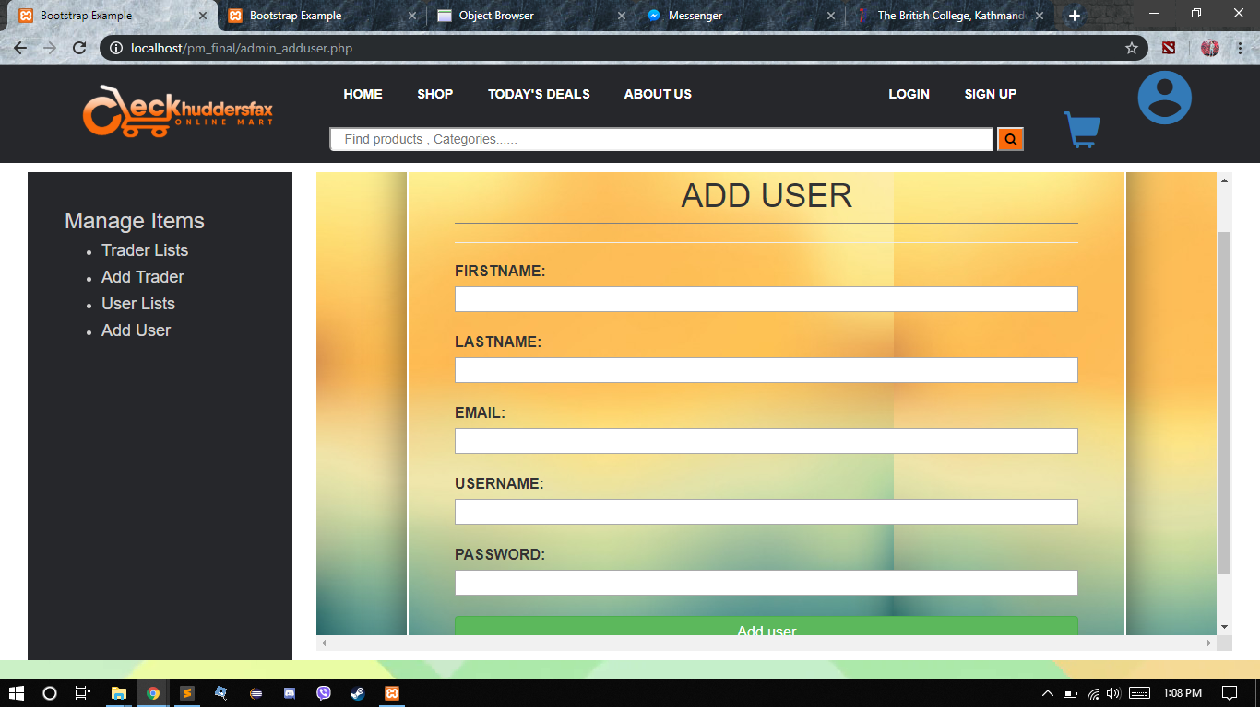

Admin can also add user by adding their name, last name, email, username and password.